|  |  |  |  |
| --- | --- | --- | --- |
| Test Plan Name: | PCT_WF_ DiagnosticList_Cardiology |  |  |
| Solution(s): | PowerChart Message Center |  |  |
| Created Date: | 20-03-2015 | No. Of Steps Requiring Evidence | 3 |
| Enviroment: | Citrix | Operating System: | Win7 |
| Associate ID: | MR029157 | Domain: | Integration |
| Test Data: | N/A |  |  |

Pre-Requisites:

Actual Evidence:

|  |  |  |  |
| --- | --- | --- | --- |
| Step No: | Step 2 | Status: | Pass |
| Comments: |  |  |  |

Evidence:

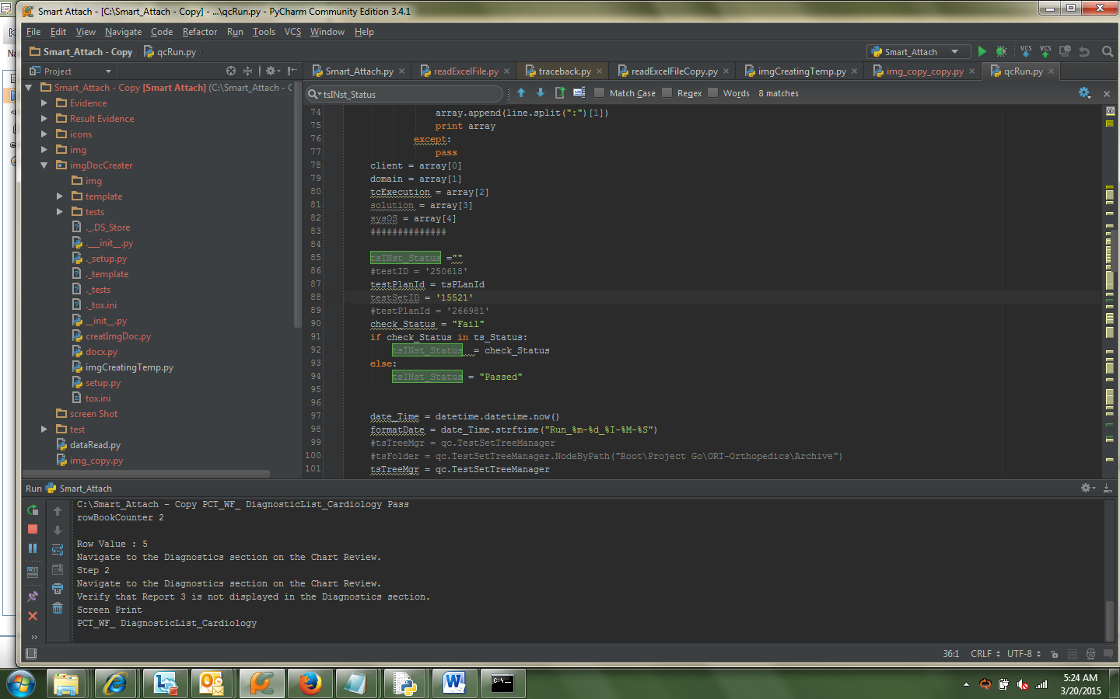

|  |  |  |  |
| --- | --- | --- | --- |
| Step No: | Step 4 | Status: | Pass |
| Comments: |  |  |  |

Evidence:

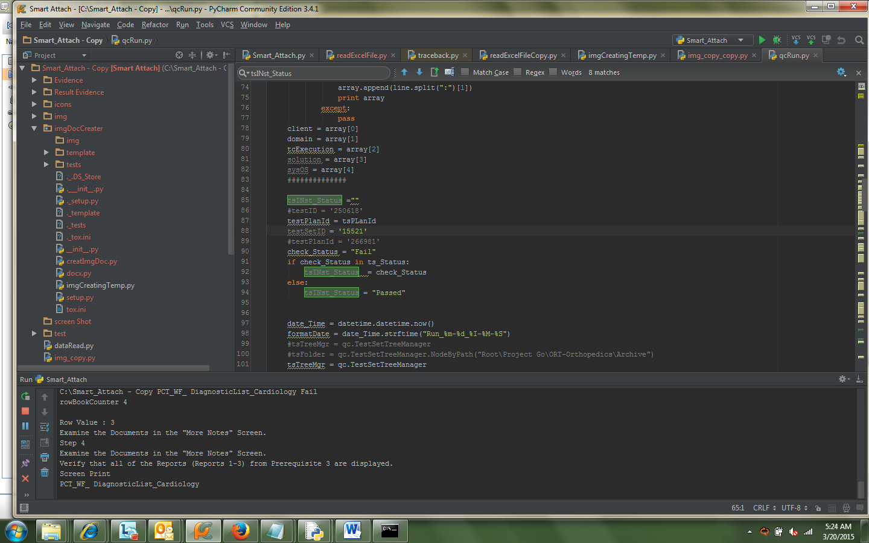

|  |  |  |  |
| --- | --- | --- | --- |
| Step No: | Step 5 | Status: | Fail |
| Comments: |  |  |  |

Evidence:

